**Tutorial Web UI Automation**

**serenity-junit-archetype**

**Serenity + Junit**

# Install Maven

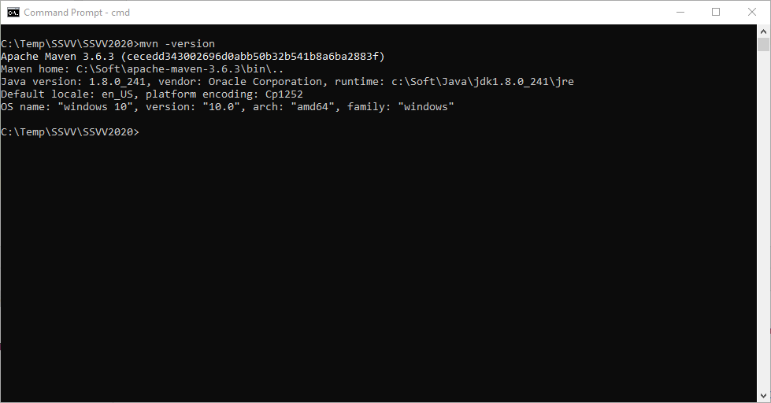

# Create Maven Project

2.a.

* click **Start** and open a Command prompt window with **cmd**
* use the command: mvn archetype:generate

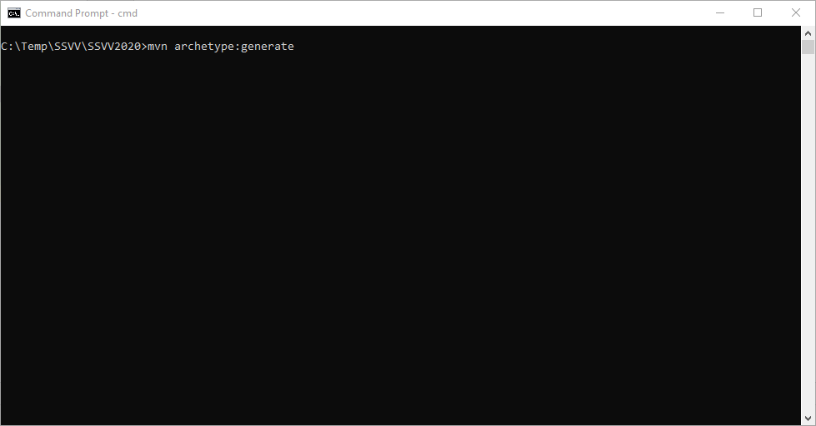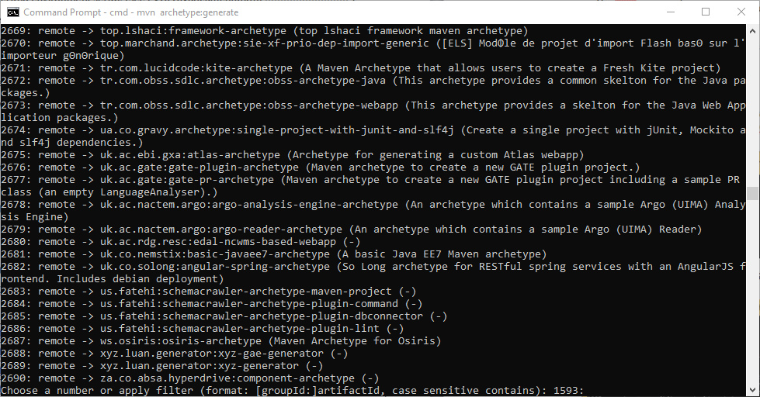

2.b.

* Display the options for the Serenity archetype
* Enter option …> serenity

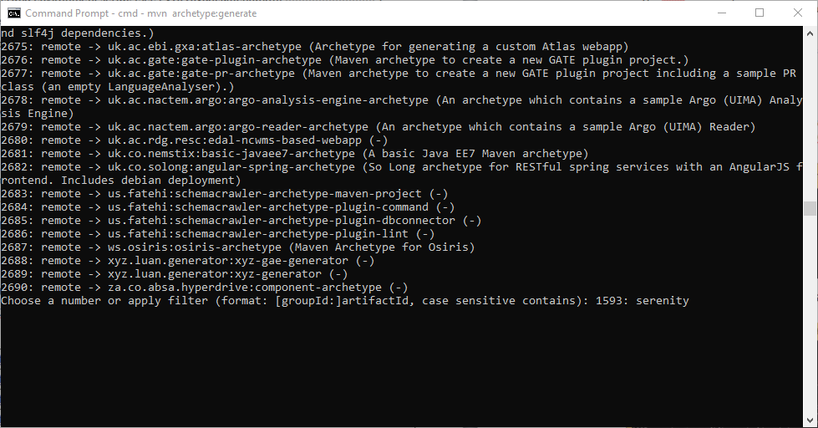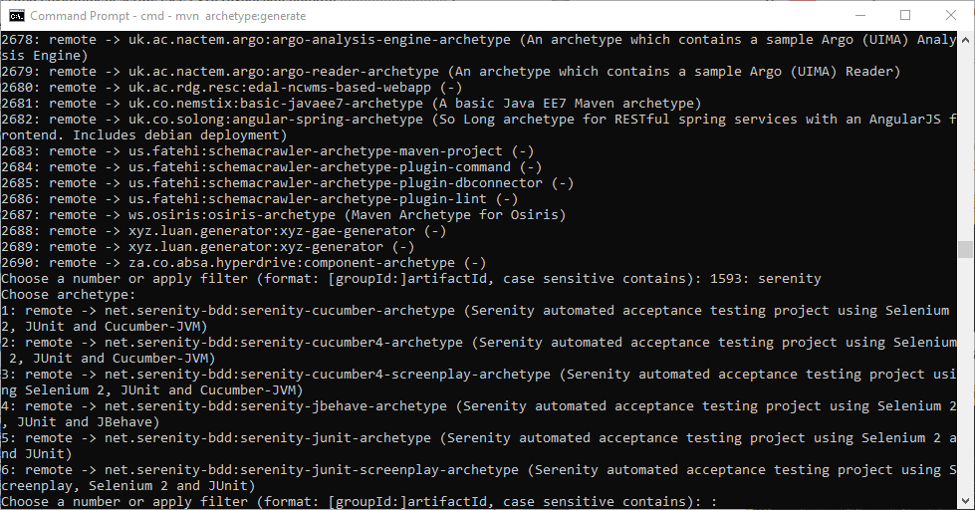

2.c.

* Option 5 is selected (**serenity-junit-archetype) ….>5**
* Select then version 12 (1.2.0). This is the version that worked. (You may try other version.)

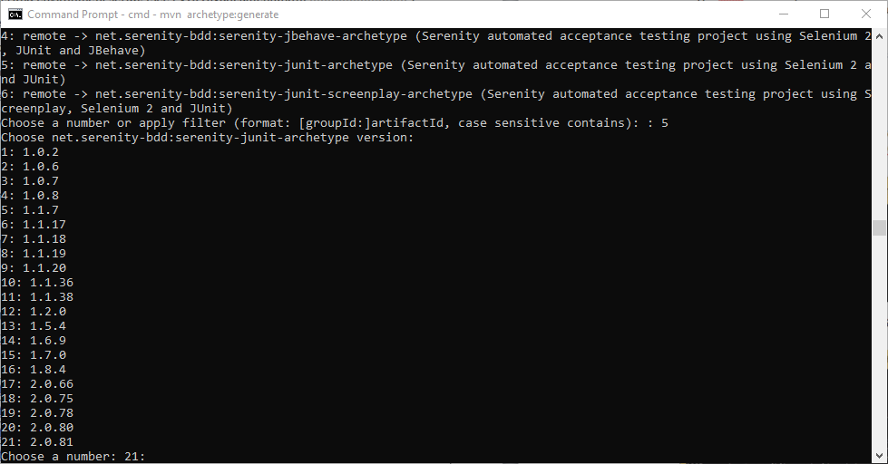

2.d. Establish properties values for Maven project

* **groupId:** **SerenityWithJUnit**
* **artifactId:** **SerenityWithJUnitPrj**
* **version: <enter>**
* **package : <enter>**
* **at the end the properties of the project are confirmed with command “y”**

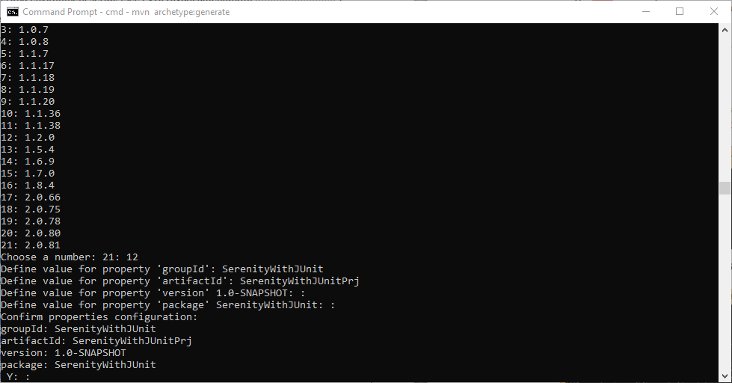

## Open the created Project in IntelliJ

3.a. In pom.xml file change Firefox with Chrome

<properties>  
 <project.build.sourceEncoding>UTF-8</project.build.sourceEncoding>  
 <serenity.version>1.2.2-rc.1</serenity.version>  
 <webdriver.driver>chrome</webdriver.driver>  
</properties>

3.b. download chrome driver and set the Path variable

* Driver for chrome

<https://sites.google.com/a/chromium.org/chromedriver/downloads>

* The drivers are downloaded, unzipped and saved to a folder, eg c:\Temp\drivers
* the path to the folder containing the web browser drivers, i.e. c:\Temp\drivers, is added to the Path environment variable

3.c. Add in the file “serenity.properties” file in the **IntelliJ project**

webdriver.driver=chrome

webdriver.chrome.driver = C:\\Temp\\drivers\\chromedriver.exe

3.d .add VM options: menu Run->Edit configurations….-> VM options:

-Dwebdriver.chrome.driver="c:\\Temp\\drivers\\chromedriver.exe"

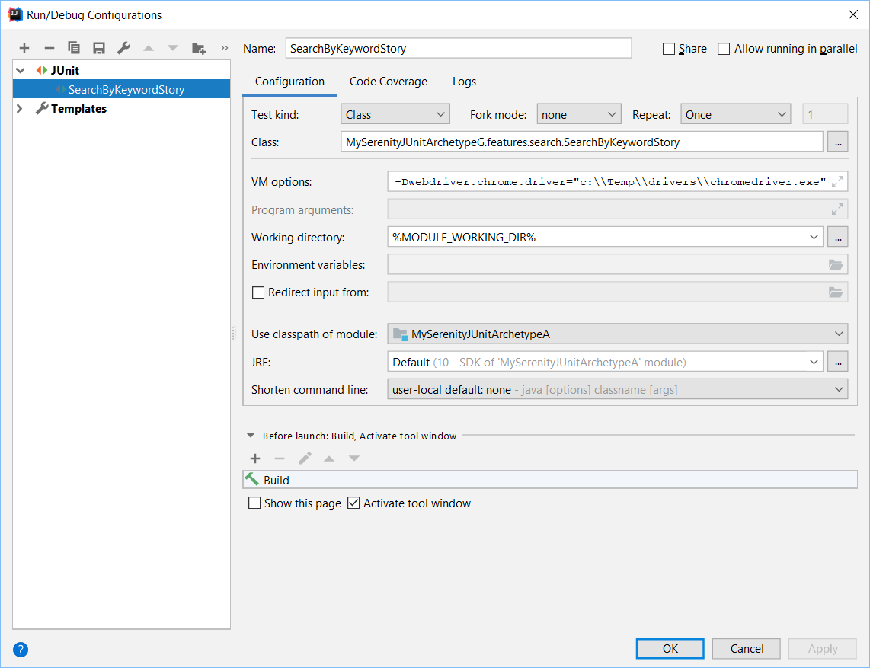

## Run as JUnit test

1. In ProjectExplorer- Right-click on a TestCase (e.g.

**SearchByKeywordStory )** and select Run

1. The Chrome browser is opened and the definitions for "pear" and "apple" are searched.
2. 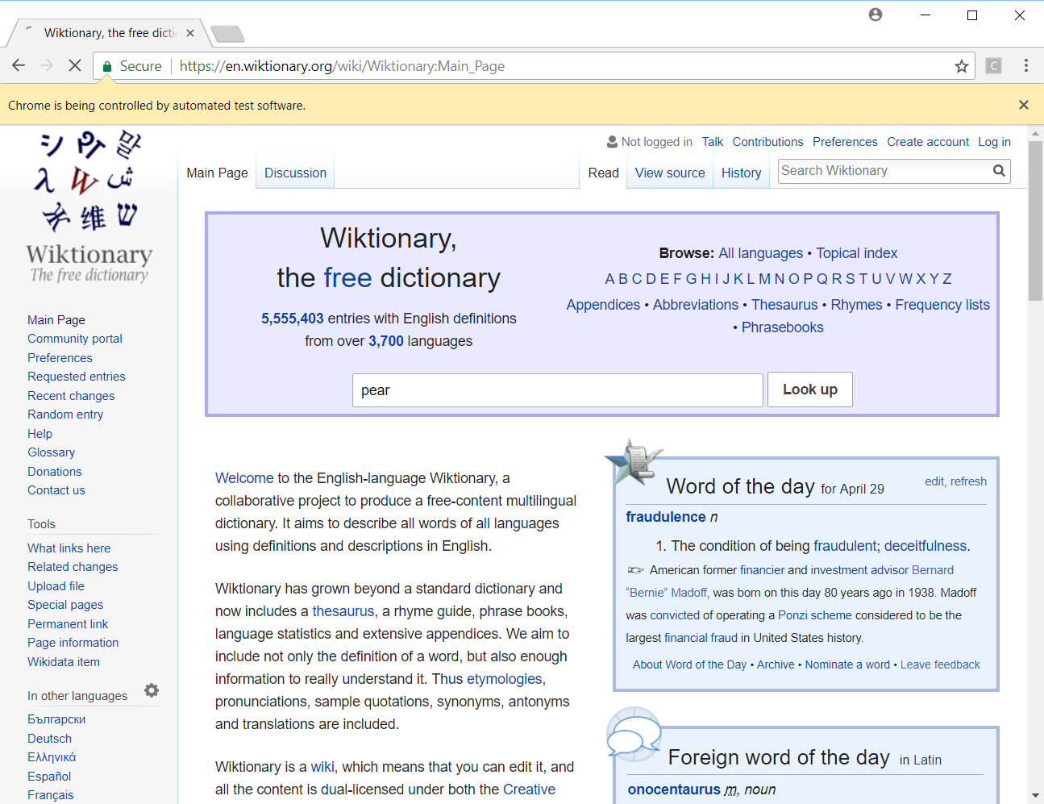

# Obtaining the documentation for the executed test cases

1. Add in the file “serenity.properties” file in the **IntelliJ project**

webdriver.driver=chrome

webdriver.chrome.driver = C:\\Temp\\drivers\\chromedriver.exe

[Option 1]

1. **IntelliJ 🡪 View 🡪Tool Windows 🡪Maven Projects**
2. Select *Lifecycle*-> the “verify” option
3. the generated report will be saved in the project folder in \target\ site\serenity;

[Option 2]

* click **Start** and open a Command prompt window with **cmd**
* Remark: execute the command from the project directory
* ...>mvn serenity:aggregate
* The generated report will be saved in the folder **\target\site\serenity**

# Viewing the Serenity report

* in the project directory ...\target\site\serenity\index.html

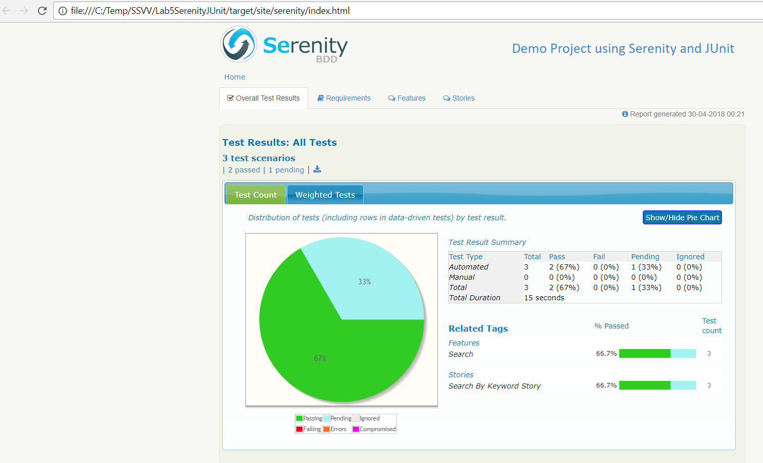

# Test Data Driven - data for test from csv file

* create the csv file *WikiTestData.csv* with the content:
  + first line indicate the structure of the table with input data
* next lines contain input data for individual test cases.

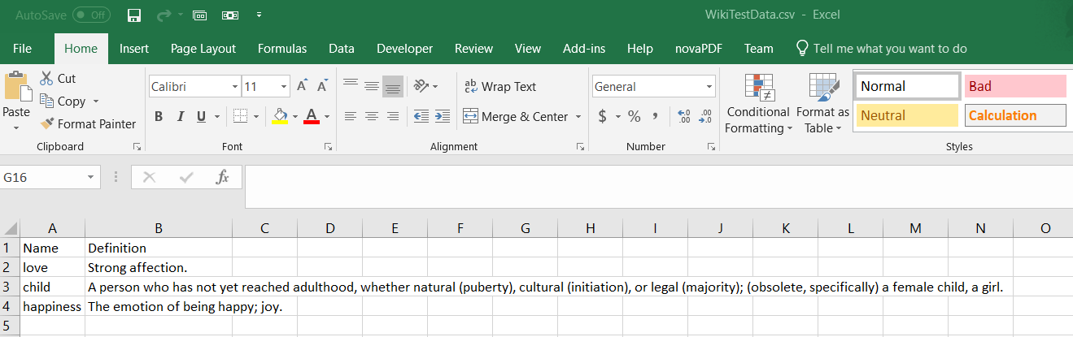

* add the csv file to the src/test/resources directory
* add a new class to run with Ddt with Parameterized Runner (see the class below)
* run (see Section 3 of the current document)
* obtaining documentation (see Section 4 of the current document)
* view the serenity report (see Section 5 of the current document)
* package WikiExampleGroup.features.search;  
    
  import net.serenitybdd.junit.runners.SerenityParameterizedRunner;  
  import net.thucydides.core.annotations.Issue;  
  import net.thucydides.core.annotations.Managed;  
  import net.thucydides.core.annotations.ManagedPages;  
  import net.thucydides.core.annotations.Steps;  
  import net.thucydides.core.pages.Pages;  
  import net.thucydides.junit.annotations.Qualifier;  
  import net.thucydides.junit.annotations.UseTestDataFrom;  
    
  import org.junit.Test;  
  import org.junit.runner.RunWith;  
  import org.openqa.selenium.WebDriver;  
    
  import Lab5SerenityJUnitPrj.steps.serenity.EndUserSteps;  
    
  @RunWith(SerenityParameterizedRunner.class)  
  @UseTestDataFrom("src/test/resources/WikiTestData.csv")  
  public class SearchByKeywordStoryDdt {  
    
   @Managed(uniqueSession = true)  
   public WebDriver webdriver;  
    
   @ManagedPages(defaultUrl = "http://en.wiktionary.org/wiki/Wiktionary")  
   public Pages pages;  
    
   public String name;  
   public String definition;  
     
   @Qualifier  
   public String getQualifier() {  
   return name;  
   }  
     
   @Steps  
   public EndUserSteps endUser;  
    
   @Issue("#WIKI-1")  
   @Test  
   public void searchWikiByKeywordTestDDT() {  
   endUser.is_the_home_page();  
   endUser.looks_for(getName());  
   endUser.should_see_definition(getDefinition());  
   }  
     
   public String getName() {  
   return name;  
   }  
    
   public void setName(String name) {  
   this.name = name;  
   }  
    
   public String getDefinition() {  
   return definition;  
   }  
    
   public void setDefinition(String definition) {  
   this.definition = definition;  
   }  
    
  }

**Test case class that is parametrized using a csv file**